Inglés

Miguel Ángel Domínguez Llorente
2025-2026
UD3.-mOVING ON
C.I.F.P A CARBALLEIRA

Índice
1.Use of english. The future time 2
1.1 Practise 3
2. Vocabulary 6

1.Use of english. The future time
Future simple
will+infinitive
uses
Present Progressive
be (present) and verb + ing
uses
be going to
uses
Present simple
uses

1.1 Practise

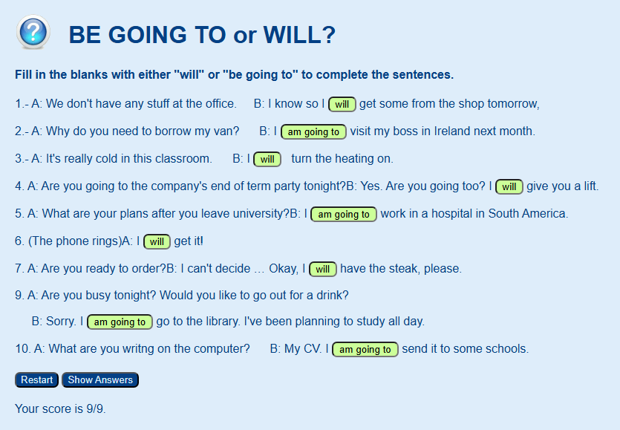

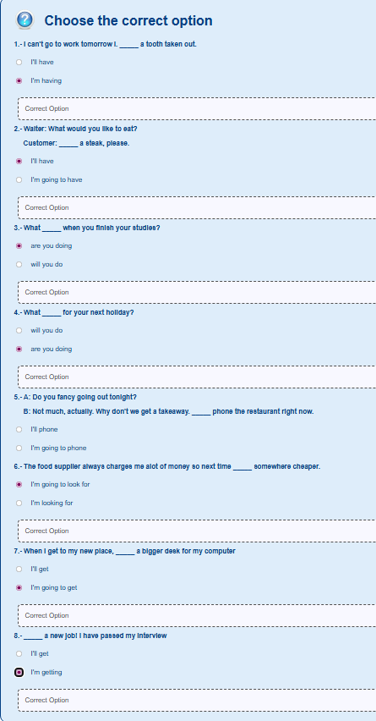

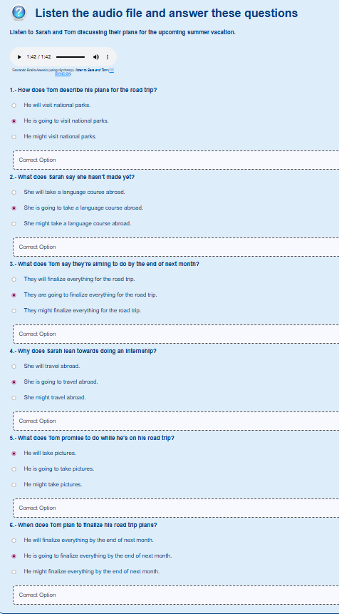

2. Vocabulary
This vocabulary is focus in workplace

- Self-Introduction
- Guide a meeting
- Establishing the agenda
- Assigning action points for completion
- How to interrupt a discussion politely
- Posing Question Introducing a topic
- Concluding a presentation
- Addressing question
2.1Interactive video
[in page ]

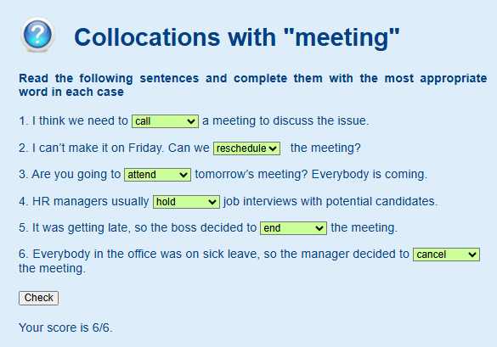
2.2 Activities: Collocations whit “meeting”.
Vocabulary
hold – Esperar – verbo regular
reschedule – reprogramar – verbo – schedule – programar/horario – palabra raiz
call – llamar - verbo
attend – atender/asistir - verbo
cancel – cancelar - verbo
end – final /
attend
Response

Activity
Vocabulary
- to get the ball rolling (verb) – to make a start with something.
- to wrap (something) up (verb) – to finish something.
- to brainstorm (verb) – to generate lots of ideas in a group.
- pre-meeting (noun) – a meeting to prepare for a subsequent meeting.
- chair (noun) – a person in charge of a meeting.
- minutes (noun) – written notes documenting what was said in a meeting.
Response

Reading

Listening

Writting

Speaking

